**19K-1043**

**Salman Ahmed Khan**

**Computer Network Lab 01**

1. **Find the IP address of the computer you are currently using.**

Command: ipconfig /all

IP Address: 172.16.11.109

1. **Find the IP address of the computer you are currently using, plus MAC address, plus**

**whether DHCP is turned on.**

Command: ipconfig /all

IP Address: 172.16.11.109

MAC Address: 94-DE-80-34-9D-8E

DHCP Server: 172.16.5.120

1. **Display the host name of the computer.**

Command: hostname

HostName: L01D19

1. **Check for basic IP connectivity between two computers by name and IP address. How can basic IP connectivity be checked? What are the reasons why there is no connectivity?**

Command: tracert

Reason: Disconnection happen due to some interrupt while making connection. The hops failed due to unable connection.

1. **Show the MAC address of the host.**

Command: ipconfig /all

MAC Address: 94-DE-80-34-9D-8E

1. **Show what shared resources are available on the host.**

Command: net share

Share Resource: C:\Windows, C:\, D:\

1. **Find out which ports on your host are connected to applications. Connect the browser to some external web page before running the appropriate command.**

Command: nestat

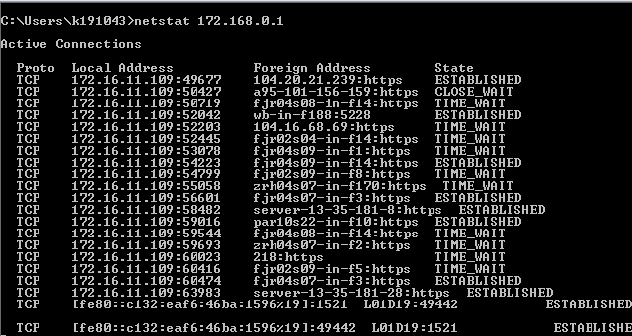

1. **Find all other hosts available on the network.**

Command: nmap

1. **Show the address of the gateway.**

Command: ipconfig

Answer: 172.16.11.1

1. **Find the path of routers to www.google.com.What is its IP address? How many hops involved in the path?**

Command: ping [www.google.com](http://www.google.com)

tracert 142.250.181.100

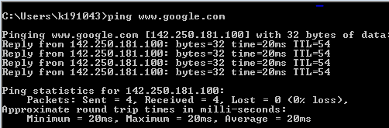

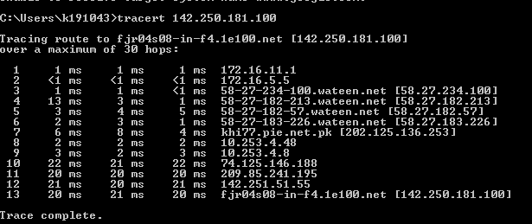

Hops: 30

Path: 13

1. **A ping to 192.168.0.2 works but a ping to the machine’s name “blue_machine” fails. What could be wrong?**

**Answer:** Host name does not exist.

1. **Which type of cable will you use to connect in a normal home installation? Give reasons.**

**Answer:** We will use Straight Through cables.

1. **Can you connect a Switch to another Switch or a router to a PC using a straight-**

**through cable? Explain your answer.**

**Answer:** We can not connect a switch to another switch with a straight through cable as it is used to connect different devices. However, a router to a PC can be connect with straight through.

1. **Write a brief report on your home network or any organizational network**

**including topology.**

**Answer:** In FAST NUCES, star topology network is used to connect devices.

1. **On which OSI layer does the following devices operate? Hub, Switch, Router**

**Answer:** Hub operate in Physical layer, Switch operate in Data link layer and Router operate in Network Layer.